Frequency tables for test files:

Test1: Small Text file

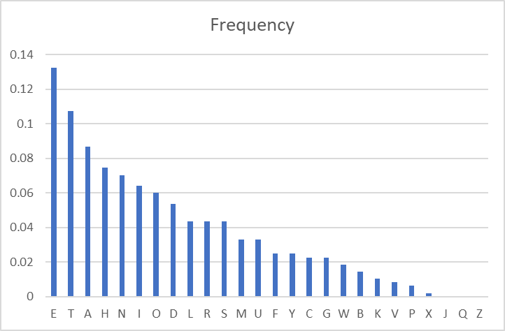

Test2:

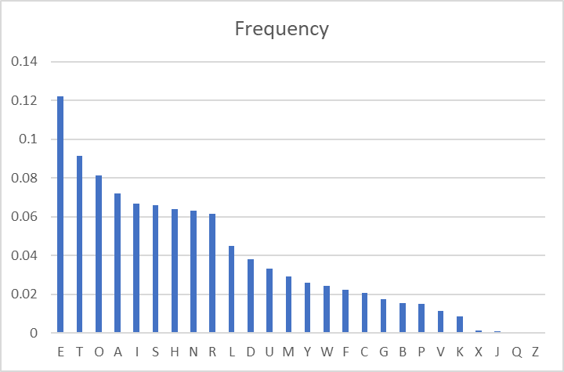

Wiki Average:

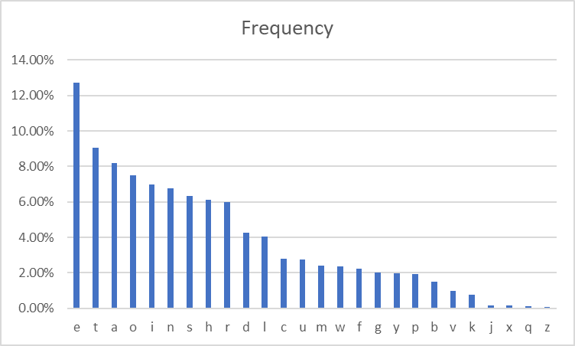

Provided Plaintext:

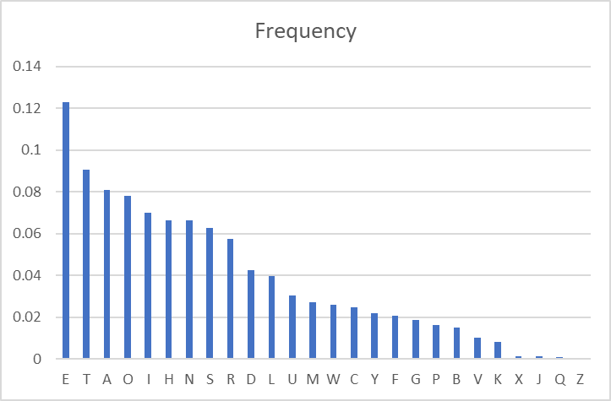

Cyphertext:

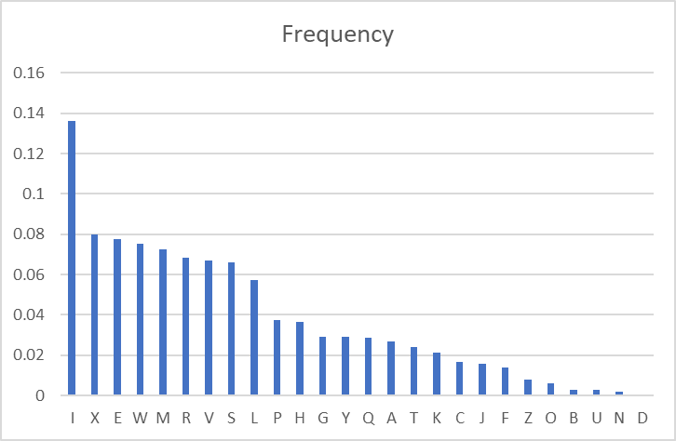

Average:

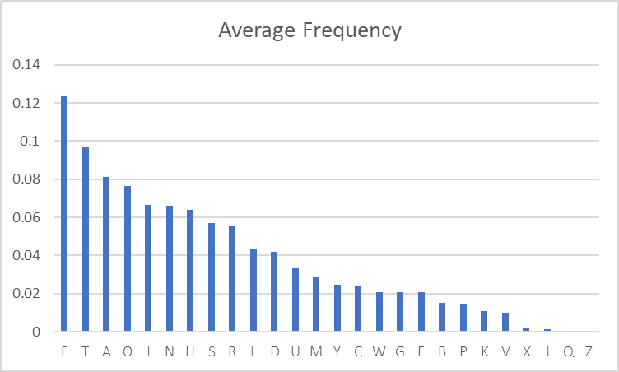

My average for the frequency analysis was slightly different to the actual average. This resulted in a larger reliance on manual tuning in the decryption stage if this assignment. I suspect that my average is skewed slightly due to the first test using a small file. I used this filled in the early stages of development.

**Cryptanalysis:**

First decryption attempt using my Frequency result:

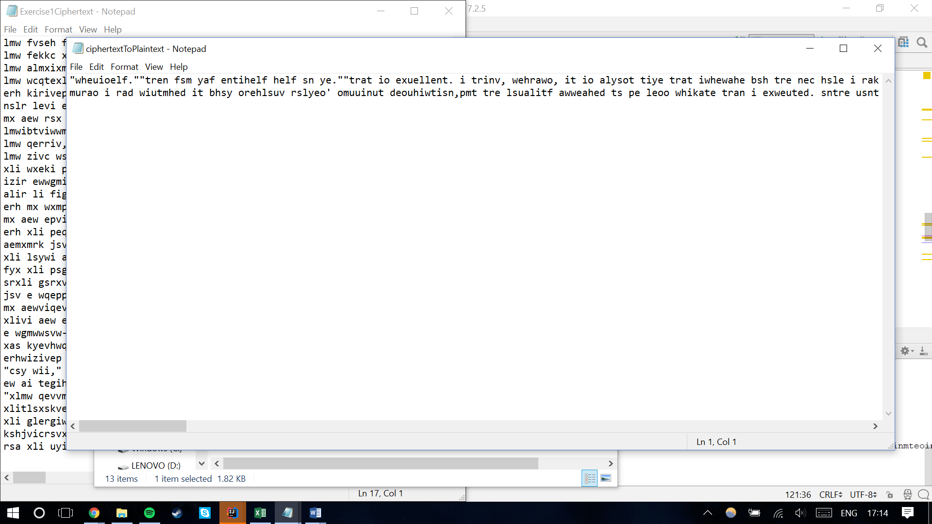

Second decryption attempt using frequencies from Wiki: 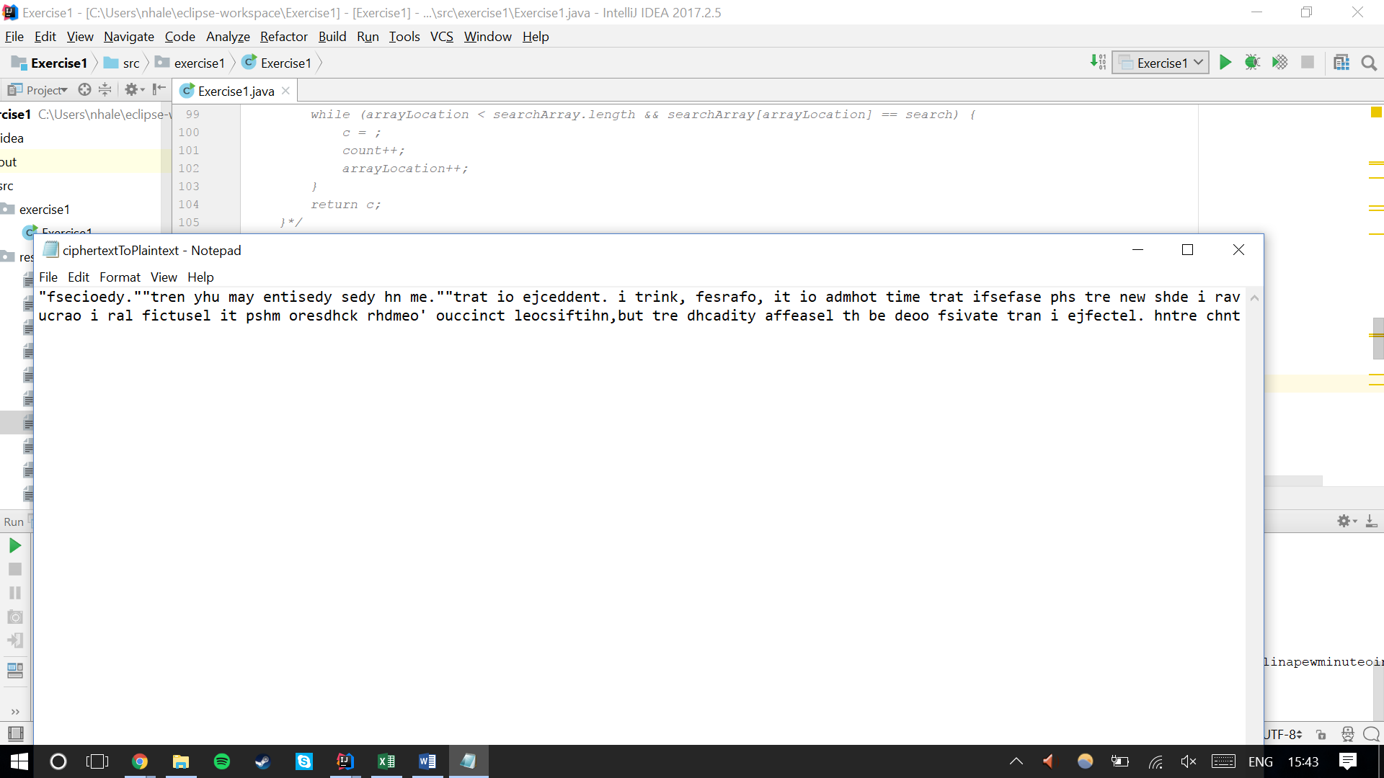

I compared the two and began tuning the decryption string

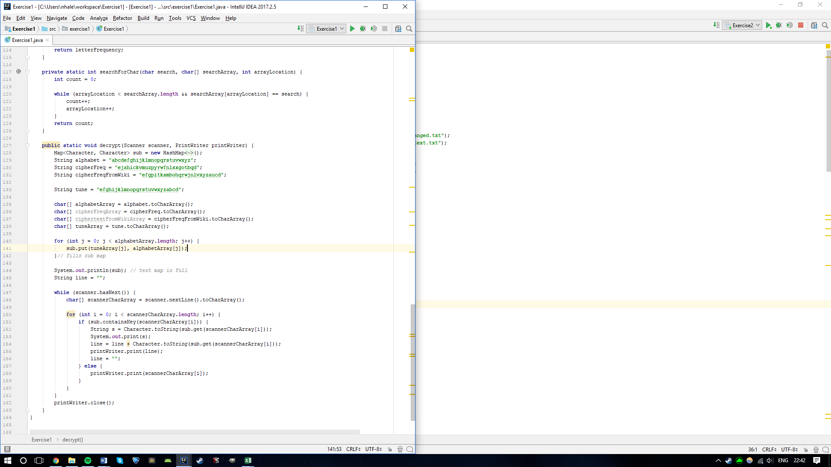

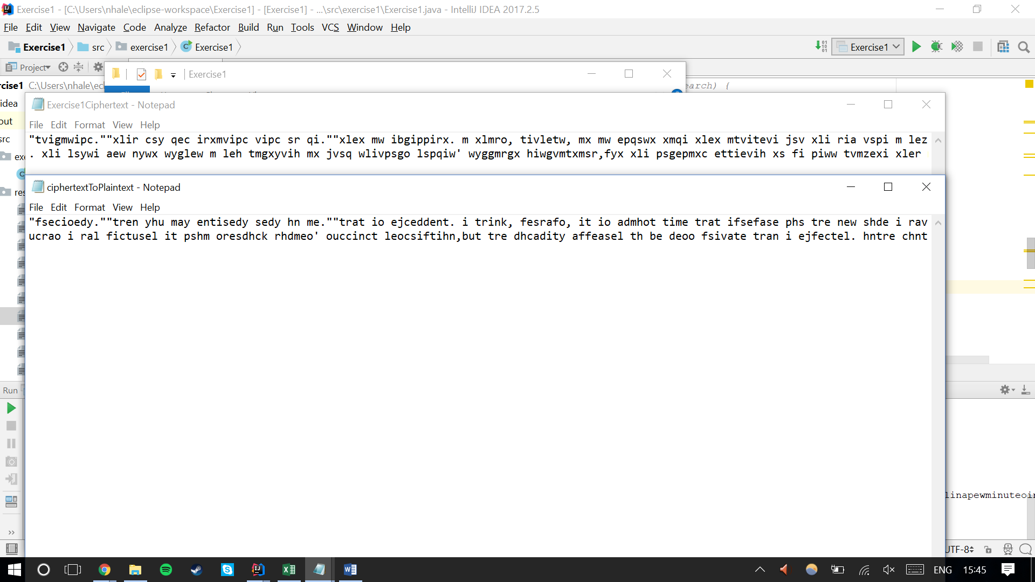

I use fully and partially complete words in manual tuning. With the works “trink” and “tre” I made the assumption that “l” should be decrypted to “h” instead of “r”. I modified my decryption and used this process to find the remaining letter combinations and the plaintext was successfully decrypted. When the tuning process was complete I realised that the file was encrypted by shifting 4 places.

Final PlainText:

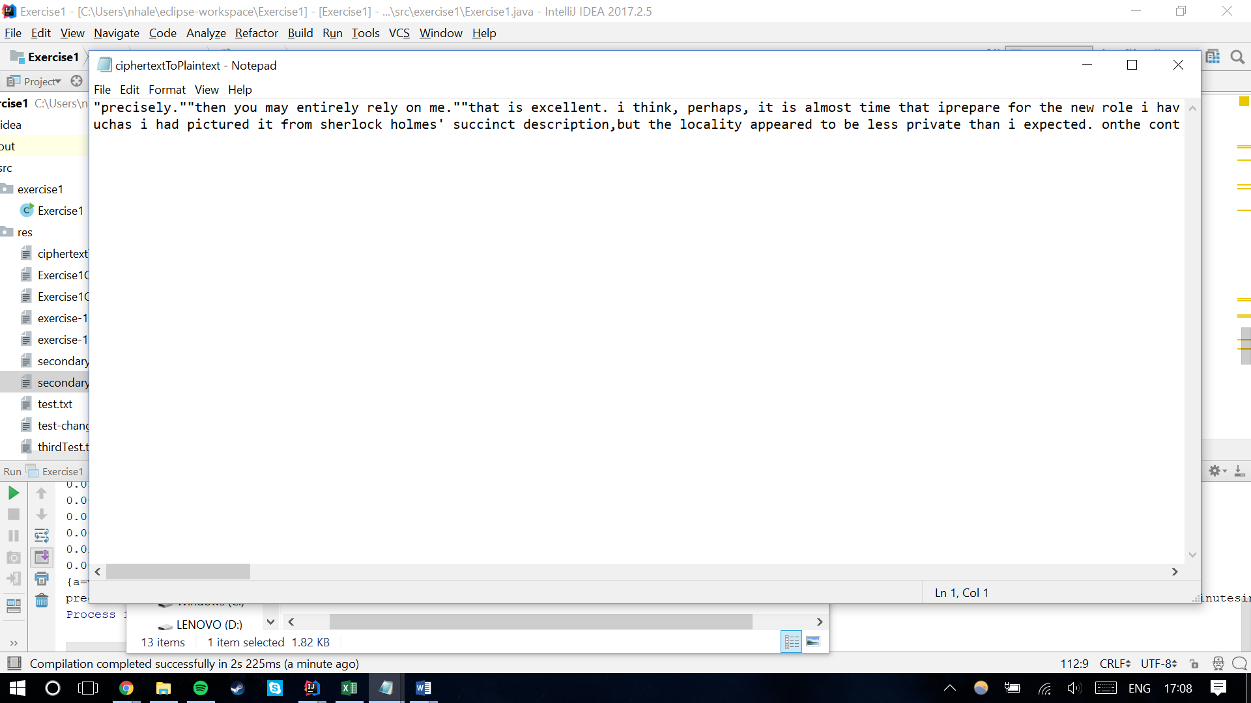

PlainText:

"precisely.""then you may entirely rely on me.""that is excellent. i think, perhaps, it is almost time that iprepare for the new role i have to play."he disappeared into his bedroom and returned in a few minutes inthe character of an amiable and simple-minded nonconformistclergyman. his broad black hat, his baggy trousers, his whitetie, his sympathetic smile, and general look of peering andbenevolent curiosity were such as mr. john hare alone could haveequalled. it was not merely that holmes changed his costume. hisexpression, his manner, his very soul seemed to vary with everyfresh part that he assumed. the stage lost a fine actor, even asscience lost an acute reasoner, when he became a specialist incrime.it was a quarter past six when we left baker street, and it stillwanted ten minutes to the hour when we found ourselves inserpentine avenue. it was already dusk, and the lamps were justbeing lighted as we paced up and down in front of briony lodge,waiting for the coming of its occupant. the house was just suchas i had pictured it from sherlock holmes' succinct description,but the locality appeared to be less private than i expected. onthe contrary, for a small street in a quiet neighbourhood, it wasremarkably animated. there was a group of shabbily dressed mensmoking and laughing in a corner, a scissors-grinder with hiswheel, two guardsmen who were flirting with a nurse-girl, andseveral well-dressed young men who were lounging up and down withcigars in their mouths."you see," remarked holmes, as we paced to and fro in front ofthe house, "this marriage rather simplifies matters. thephotograph becomes a double-edged weapon now. the chances arethat she would be as averse to its being seen by mr. godfreynorton, as our client is to its coming to the eyes of hisprincess. now the question is, where are we to find thephotograph?""where, indeed?"